**MINI PROJECT**

**Controller Area Network Transmission Module Using Verilog HDL**

**DESIGN MODULE FOR THE CAN TRANSMISSION:**

// Code your design here

module can_tx(

output reg tx,

output reg can_bitstuff,

output reg txing,

input rx,

input[10:0] address,

input clk,

input baud_clk,

input rst,

input [7:0] data,

input send_data,

input bitstuffed_output,

input clear_to_tx

);

assign rx_buf = rx;

parameter all_ones = 15'b111111111111111;

parameter idle = 8'h0, start_of_frame = 8'h1, addressing =8'h2 ,rtr = 8'h3 ,ide = 8'h4, reserve_bit = 8'h5, num_of_bytes = 8'h6,

data_out = 8'h7, crc_out = 8'h8, crc_delimiter = 8'h9 , ack = 8'hA, ack_delimiter = 8'hB, end_of_frame = 8'hC, waiting = 8'hD;

parameter bytes = 5'd8;

reg[10:0] address_count = 0, crc_count = 0, eof_count = 0 , data_bit_count = 0, data_byte_count = 0;

reg[7:0] c_state=0, n_state=0;

initial txing = 0;

reg[14:0] crc_output, crc_holder;

wire one_shotted_send;

wire[14:0] crc_buff;

CRC cyclic_red_check(data, one_shotted_send, crc_buff,rst,clk);//caliing crc module

OneShot os(send_data, clk, rst, one_shotted_send);//calling one shot pulse module

always @(crc_buff or crc_holder) begin

if(crc_buff != all_ones)

crc_output <= crc_buff;

else

crc_output <= crc_holder;

end

always @ (posedge clk or posedge rst) begin

if(rst == 1) begin

crc_holder <= 15'd0;

end

else begin

crc_holder <= crc_output;

end

end

//Update Logic

always @ (posedge baud_clk or posedge rst) begin

if(rst == 1) begin

c_state <= 32'd0;

end

else begin

c_state <= n_state;

end

end

//Counting Logic

always @ (posedge baud_clk) begin

case(c_state)

idle: begin

address_count <= 11'd0;

data_bit_count<= 11'd0;

data_byte_count<= 11'd0;

crc_count <= 11'd0;

eof_count <= 11'd0;

end

waiting: begin

address_count <= 11'd0;

data_bit_count<= 11'd0;

data_byte_count<= 11'd0;

crc_count <= 11'd0;

eof_count <= 11'd0;

end

start_of_frame:begin

address_count <= 11'd0;

data_bit_count<= 11'd0;

data_byte_count<= 11'd0;

crc_count <= 11'd0;

eof_count <= 11'd0;

end

addressing: begin

address_count <= address_count + 1'b1;

data_bit_count<= 11'd0;

data_byte_count<= 11'd0;

crc_count <= 11'd0;

eof_count <= 11'd0;

end

rtr: begin

address_count <= 11'd0;

data_bit_count<= 11'd0;

data_byte_count<= 11'd0;

crc_count <= 11'd0;

eof_count <= 11'd0;

end

ide: begin

address_count <= 11'd0;

data_bit_count<= 11'd0;

data_byte_count<= 11'd0;

crc_count <= 11'd0;

eof_count <= 11'd0;

end

reserve_bit: begin

address_count <= 11'd0;

data_bit_count<= 11'd0;

data_byte_count<= 11'd0;

crc_count <= 11'd0;

eof_count <= 11'd0;

end

num_of_bytes: begin

address_count <= 11'd0;

data_bit_count<= 11'd0;

data_byte_count<= data_byte_count +1'b1;

crc_count <= 11'd0;

eof_count <= 11'd0;

end

data_out: begin

address_count <= 11'd0;

data_bit_count<= data_bit_count +1'b1;

data_byte_count<= 11'd0;

crc_count <= 11'd0;

eof_count <= 11'd0;

end

crc_out: begin

address_count <= 11'd0;

data_bit_count<= 11'd0;

data_byte_count<= 11'd0;

crc_count <= crc_count + 1'b1;

eof_count <= 11'd0;

end

crc_delimiter: begin

address_count <= 11'd0;

data_bit_count<= 11'd0;

data_byte_count<= 11'd0;

crc_count <= 11'd0;

eof_count <= 11'd0;

end

ack: begin

address_count <= 11'd0;

data_bit_count<= 11'd0;

data_byte_count<= 11'd0;

crc_count <= 11'd0;

eof_count <= 11'd0;

end

ack_delimiter:begin

address_count <= 11'd0;

data_bit_count<= 11'd0;

data_byte_count<= 11'd0;

crc_count <= 11'd0;

eof_count <= 11'd0;

end

end_of_frame: begin

address_count <= 11'd0;

data_bit_count<= 11'd0;

data_byte_count<= 11'd0;

crc_count <= 11'd0;

eof_count <= eof_count +1'b1;

end

default: begin

address_count <= 11'd0;

data_bit_count<= 11'd0;

data_byte_count<= 11'd0;

crc_count <= 11'd0;

eof_count <= 11'd0;

end

endcase

end

//Next State Logic

always @ (c_state or rx_buf or data or send_data or address_count or bitstuffed_output or data_byte_count

or data_bit_count or crc_count or eof_count or clear_to_tx or crc_output) begin

case(c_state)

idle: begin

if(send_data && clear_to_tx) begin

n_state <= start_of_frame;

end

else begin

n_state <= idle;

end

end

start_of_frame: begin

if(!rx_buf) begin

n_state <= addressing;

end

else begin

n_state <= waiting;

end

end

waiting: begin

if(send_data && clear_to_tx) begin

n_state <= start_of_frame;

end

else begin

n_state <= waiting;

end

end

addressing: begin

if(rx_buf != bitstuffed_output) begin

n_state <= waiting; //Lost Arbitration

end

else if(address_count == 11'd10) begin

n_state <= rtr;

end

else begin

n_state <= addressing;

end

end

rtr: begin

n_state <= ide;

end

ide: begin

n_state <= reserve_bit;

end

reserve_bit: begin

n_state <= num_of_bytes;

end

num_of_bytes: begin

if(data_byte_count == 11'd3) begin

n_state <= data_out;

end

else begin

n_state <= num_of_bytes;

end

end

data_out: begin

if(data_bit_count == 11'd63) begin

n_state <= crc_out;

end

else begin

n_state <= data_out;

end

end

crc_out: begin

if(crc_count == 11'd14) begin

n_state <= crc_delimiter;

end

else begin

n_state <= crc_out;

end

end

crc_delimiter: begin

n_state <= ack;

end

ack: begin

n_state <= ack_delimiter;

end

ack_delimiter: begin

n_state <= end_of_frame;

end

end_of_frame: begin

if(eof_count == 11'd6) begin

n_state <= idle;

end

else begin

n_state <= end_of_frame;

end

end

default:

begin

n_state <= idle;

end

endcase

end

//Output Logic

always @(c_state or address or data or crc_output or crc_count or data_byte_count or data_bit_count or address_count) begin

case(c_state)

idle: begin

tx <= 1;

can_bitstuff <= 0;

txing <= 1'b0;

end

addressing: begin

tx <= address[11'd10-address_count];

can_bitstuff <= 1;

txing <= 1'b1;

end

start_of_frame: begin

tx<= 0;

can_bitstuff <= 1'b0;

txing <= 1'b1;

end

rtr: begin

tx <= 0;

can_bitstuff <= 1;

txing <= 1'b1;

end

ide: begin

tx <= 0;

can_bitstuff <= 1;

txing <= 1'b1;

end

reserve_bit: begin

tx <= 0;

can_bitstuff <= 1;

txing <= 1'b1;

end

num_of_bytes: begin

tx <= bytes[11'd3-data_byte_count];

can_bitstuff <= 1;

txing <= 1'b1;

end

data_out: begin

tx <= data[11'd63-data_bit_count];

can_bitstuff <= 1;

txing <= 1'b1;

end

crc_out: begin

tx <= crc_output[11'd14-crc_count];

can_bitstuff <= 1;

txing <= 1'b1;

end

crc_delimiter: begin

tx <= 1;

can_bitstuff <= 0;

txing <= 1'b1;

end

ack: begin

tx <= 1;

can_bitstuff <= 0;

txing <= 1'b1;

end

ack_delimiter:begin

tx <= 1;

can_bitstuff <= 0;

txing <= 1'b1;

end

end_of_frame: begin

tx <= 1;

can_bitstuff <= 0;

txing <= 1'b1;

end

waiting: begin

tx <= 1;

can_bitstuff <= 0;

txing <= 1'b0;

end

default: begin

tx <= 1;

can_bitstuff <= 0;

txing <= 1'b1;

end

endcase

end

endmodule

module CRC (

input [7:0] data_in,

input crc_en,

output reg [4:0] crc_out,

input clk,

input reset

);

reg [4:0] lfsr_q, lfsr_c;

always @* begin

lfsr_c[0] = data_in[7] ^ data_in[5] ^ data_in[4] ^ data_in[3] ^ data_in[0] ^ lfsr_q[4] ^ lfsr_q[3] ^ lfsr_q[2] ^ lfsr_q[0];

lfsr_c[1] = data_in[7] ^ data_in[6] ^ data_in[5] ^ data_in[2] ^ data_in[0] ^ lfsr_q[4] ^ lfsr_q[3] ^ lfsr_q[1];

lfsr_c[2] = data_in[6] ^ data_in[5] ^ data_in[4] ^ data_in[1] ^ data_in[0] ^ lfsr_q[4] ^ lfsr_q[2];

lfsr_c[3] = data_in[7] ^ data_in[5] ^ data_in[4] ^ data_in[3] ^ data_in[1] ^ lfsr_q[3] ^ lfsr_q[1] ^ lfsr_q[0];

lfsr_c[4] = data_in[6] ^ data_in[5] ^ data_in[2] ^ data_in[1] ^ lfsr_q[4] ^ lfsr_q[2] ^ lfsr_q[1] ^ lfsr_q[0];

end

always @(posedge clk, posedge reset) begin

if (reset)

lfsr_q <= 0;

else

lfsr_q <= lfsr_c;

end

always @(posedge clk) begin

crc_out <= lfsr_q;

end

endmodule

module OneShot(

input pulse,

input clk,

input rst,

output reg out

);

initial out = 0;

parameter waiting_l = 2'b00, on = 2'b01, waiting_h = 2'b10;

reg[1:0] next_state, current_state;

always @ (posedge clk or posedge rst) begin

if(rst) begin

current_state <= waiting_l;

end

else begin

current_state <= next_state;

end

end

always @ (current_state or pulse) begin

if(current_state == on) begin

next_state <= waiting_h;

end

else if(current_state == waiting_h) begin

if(pulse) begin

next_state <= waiting_h;

end

else begin

next_state <= waiting_l;

end

end

else if(pulse) begin

next_state<= on;

end

else begin

next_state<= waiting_l;

end

end

always @(current_state or rst) begin

if(rst)

out <= 1'b0;

else if(current_state == on)

out <= 1'b1;

else

out <= 1'b0;

end

endmodule

**TESTBENCH CODE:**

module can_tx_tb;

parameter CLK_PERIOD = 10;

parameter SIM_TIME = 500;

// Signals

reg clk = 0;

reg baud_clk = 0;

reg rst = 1;

reg send_data = 0;

reg bitstuffed_output = 0;

reg clear_to_tx = 1;

reg rx = 0;

reg [10:0] address = 11'd0;

reg [7:0] data = 8'd0;

reg pulse;

wire tx;

wire can_bitstuff;

wire txing;

wire out;

// Instantiate the modules

can_tx dut (

.tx(tx),

.can_bitstuff(can_bitstuff),

.txing(txing),

.rx(rx),

.address(address),

.clk(clk),

.baud_clk(baud_clk),

.rst(rst),

.data(data),

.send_data(send_data),

.bitstuffed_output(bitstuffed_output),

.clear_to_tx(clear_to_tx)

);

OneShot os (

.pulse(pulse),

.clk(clk),

.rst(rst),

.out(out)

);

// Clock generation

always #((CLK_PERIOD/2)) clk = ~clk;

always #5 baud_clk = ~baud_clk;

initial begin

rst = 1;

#20 rst = 0;

#50 send_data = 1;

#10 send_data = 0;

#100 rx = 1;

#10 rx = 0;

#50 address = 11'd123;

#70 data = 8'd255;

#150 pulse = 1;

#10 pulse = 0;

#200 $finish;

end

// Display output

always @(posedge clk) begin

$display("Time = %0t: tx = %b, can_bitstuff = %b, txing = %b, out = %b", $time, tx, can_bitstuff, txing, out);

end

initial begin

$dumpfile("dump.vcd");

$dumpvars(0);

end

endmodule

**OUTPUT:**

**Can_tx_tb**

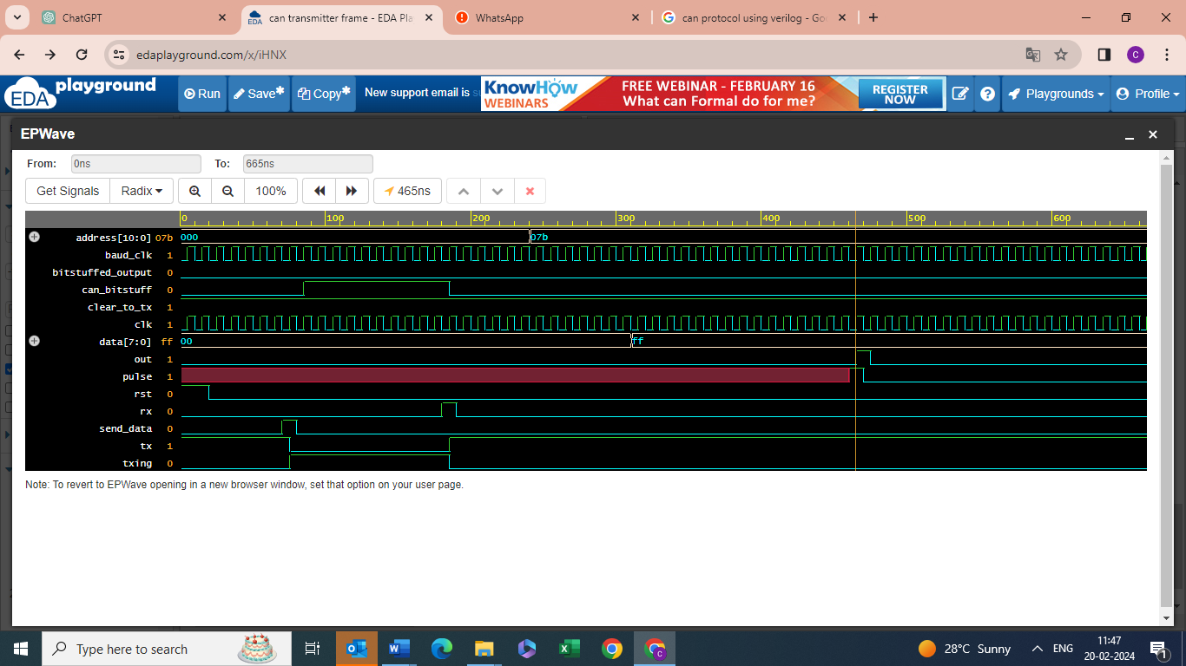

**Dut_tb:**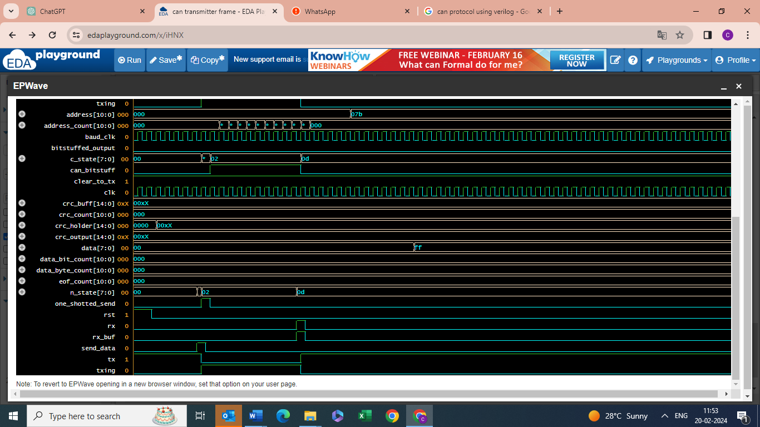

**os_tb:**

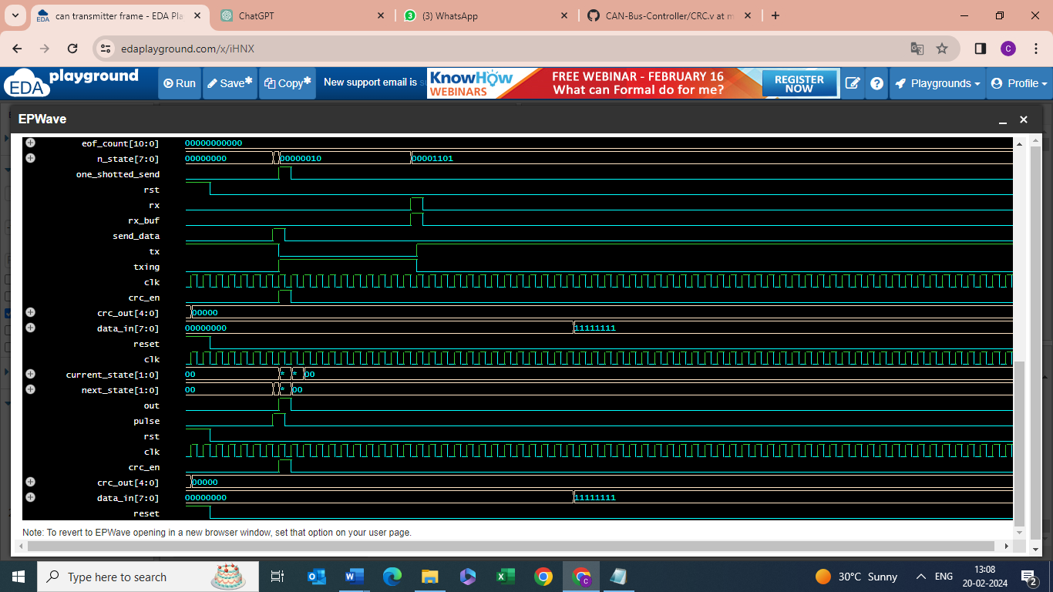

**crc_tb:**



Time = 5: tx = 1, can_bitstuff = 0, txing = 0, out = 0

Time = 15: tx = 1, can_bitstuff = 0, txing = 0, out = 0

Time = 25: tx = 1, can_bitstuff = 0, txing = 0, out = 0

Time = 35: tx = 1, can_bitstuff = 0, txing = 0, out = 0

Time = 45: tx = 1, can_bitstuff = 0, txing = 0, out = 0

Time = 55: tx = 1, can_bitstuff = 0, txing = 0, out = 0

Time = 65: tx = 1, can_bitstuff = 0, txing = 0, out = 0

Time = 75: tx = 1, can_bitstuff = 0, txing = 0, out = 0

Time = 85: tx = 0, can_bitstuff = 0, txing = 1, out = 0

Time = 95: tx = 0, can_bitstuff = 1, txing = 1, out = 0

Time = 105: tx = 0, can_bitstuff = 1, txing = 1, out = 0

Time = 115: tx = 0, can_bitstuff = 1, txing = 1, out = 0

Time = 125: tx = 0, can_bitstuff = 1, txing = 1, out = 0

Time = 135: tx = 0, can_bitstuff = 1, txing = 1, out = 0

Time = 145: tx = 0, can_bitstuff = 1, txing = 1, out = 0

Time = 155: tx = 0, can_bitstuff = 1, txing = 1, out = 0

Time = 165: tx = 0, can_bitstuff = 1, txing = 1, out = 0

Time = 175: tx = 0, can_bitstuff = 1, txing = 1, out = 0

Time = 185: tx = 0, can_bitstuff = 1, txing = 1, out = 0

Time = 195: tx = 1, can_bitstuff = 0, txing = 0, out = 0

Time = 205: tx = 1, can_bitstuff = 0, txing = 0, out = 0

Time = 215: tx = 1, can_bitstuff = 0, txing = 0, out = 0

Time = 225: tx = 1, can_bitstuff = 0, txing = 0, out = 0

Time = 235: tx = 1, can_bitstuff = 0, txing = 0, out = 0

Time = 245: tx = 1, can_bitstuff = 0, txing = 0, out = 0

Time = 255: tx = 1, can_bitstuff = 0, txing = 0, out = 0

Time = 265: tx = 1, can_bitstuff = 0, txing = 0, out = 0

Time = 275: tx = 1, can_bitstuff = 0, txing = 0, out = 0

Time = 285: tx = 1, can_bitstuff = 0, txing = 0, out = 0

Time = 295: tx = 1, can_bitstuff = 0, txing = 0, out = 0

Time = 305: tx = 1, can_bitstuff = 0, txing = 0, out = 0

Time = 315: tx = 1, can_bitstuff = 0, txing = 0, out = 0

Time = 325: tx = 1, can_bitstuff = 0, txing = 0, out = 0

Time = 335: tx = 1, can_bitstuff = 0, txing = 0, out = 0

Time = 345: tx = 1, can_bitstuff = 0, txing = 0, out = 0

Time = 355: tx = 1, can_bitstuff = 0, txing = 0, out = 0

Time = 365: tx = 1, can_bitstuff = 0, txing = 0, out = 0

Time = 375: tx = 1, can_bitstuff = 0, txing = 0, out = 0

Time = 385: tx = 1, can_bitstuff = 0, txing = 0, out = 0

Time = 395: tx = 1, can_bitstuff = 0, txing = 0, out = 0

Time = 405: tx = 1, can_bitstuff = 0, txing = 0, out = 0

Time = 415: tx = 1, can_bitstuff = 0, txing = 0, out = 0

Time = 425: tx = 1, can_bitstuff = 0, txing = 0, out = 0

Time = 435: tx = 1, can_bitstuff = 0, txing = 0, out = 0

Time = 445: tx = 1, can_bitstuff = 0, txing = 0, out = 0

Time = 455: tx = 1, can_bitstuff = 0, txing = 0, out = 0

Time = 465: tx = 1, can_bitstuff = 0, txing = 0, out = 0

Time = 475: tx = 1, can_bitstuff = 0, txing = 0, out = 1

Time = 485: tx = 1, can_bitstuff = 0, txing = 0, out = 0

Time = 495: tx = 1, can_bitstuff = 0, txing = 0, out = 0

Time = 505: tx = 1, can_bitstuff = 0, txing = 0, out = 0

Time = 515: tx = 1, can_bitstuff = 0, txing = 0, out = 0

Time = 525: tx = 1, can_bitstuff = 0, txing = 0, out = 0

Time = 535: tx = 1, can_bitstuff = 0, txing = 0, out = 0

Time = 545: tx = 1, can_bitstuff = 0, txing = 0, out = 0

Time = 555: tx = 1, can_bitstuff = 0, txing = 0, out = 0

Time = 565: tx = 1, can_bitstuff = 0, txing = 0, out = 0

Time = 575: tx = 1, can_bitstuff = 0, txing = 0, out = 0

Time = 585: tx = 1, can_bitstuff = 0, txing = 0, out = 0

Time = 595: tx = 1, can_bitstuff = 0, txing = 0, out = 0

Time = 605: tx = 1, can_bitstuff = 0, txing = 0, out = 0

Time = 615: tx = 1, can_bitstuff = 0, txing = 0, out = 0

Time = 625: tx = 1, can_bitstuff = 0, txing = 0, out = 0

Time = 635: tx = 1, can_bitstuff = 0, txing = 0, out = 0

Time = 645: tx = 1, can_bitstuff = 0, txing = 0, out = 0

Time = 655: tx = 1, can_bitstuff = 0, txing = 0, out = 0

Time = 665: tx = 1, can_bitstuff = 0, txing = 0, out = 0

$finish called from file "testbench.sv", line 68.